**LAPORAN TESTING dan DEBUG**

**NAMA : R IBRAHIM FATTAH**

**NIM : A11.2017.10582**

**KEL. : A11.4309**

* Debug AJax

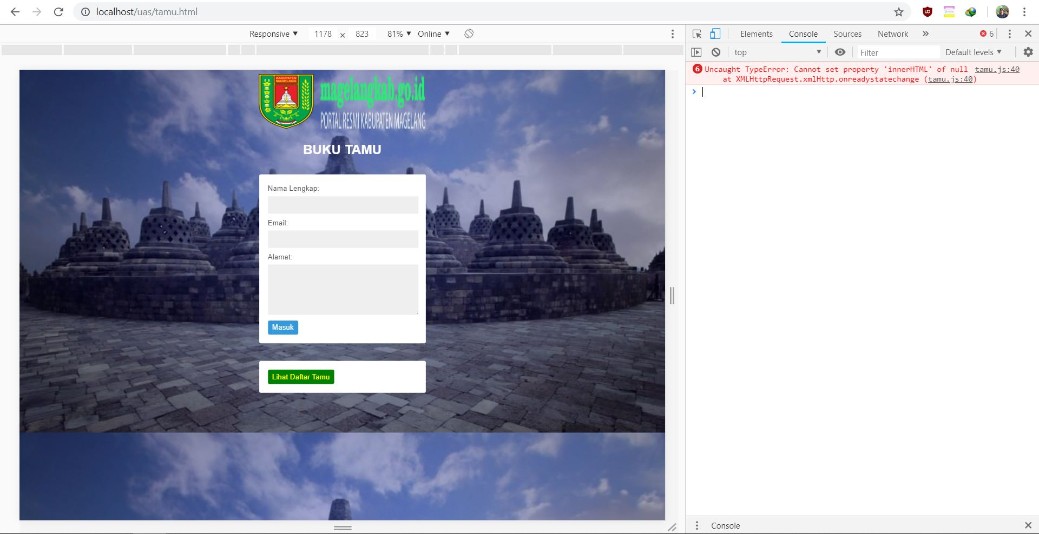

* Debug Dom

